T

TIBCO BusinessEvents: Studio Tester Tools

Tools

Product Suite | TIBCO BusinessEvents
Product | Studio Tester Tools
Product Version | 5.2.0
Initial Author | Sandip Sahoo

Copyright Notice
COPYRIGHT© 2013 TIBCO Software Inc. This document is unpublished and the foregoing notice is affixed to protect TIBCO Software Inc. in the event of inadvertent publication. All rights reserved. No part of this document may be reproduced in any form, including photocopying or transmission electronically to any computer, without prior written consent of TIBCO Software Inc. The information contained in this document is confidential and proprietary to TIBCO Software Inc. and may not be used or disclosed except as expressly authorized in writing by TIBCO Software Inc. Copyright protection includes material generated from our software programs displayed on the screen, such as icons, screen displays, and the like.
Trademarks
Technologies described herein are either covered by existing patents or patent applications are in progress. All brand and product names are trademarks or registered trademarks of their respective holders and are hereby acknowledged.
Confidentiality
The information in this document is subject to change without notice. This document contains information that is confidential and proprietary to TIBCO Software Inc. and may not be copied, published, or disclosed to others, or used for any purposes other than review, without written authorization of an officer of TIBCO Software Inc. Submission of this document does not represent a commitment to implement any portion of this specification in the products of the submitters.
Content Warranty
The information in this document is subject to change without notice. THIS DOCUMENT IS PROVIDED "AS IS" AND TIBCO MAKES NO WARRANTY, EXPRESS, IMPLIED, OR STATUTORY, INCLUDING BUT NOT LIMITED TO ALL WARRANTIES OF MERCHANTABILITY OR FITNESS FOR A PARTICULAR PURPOSE. TIBCO Software Inc. shall not be liable for errors contained herein or for incidental or consequential damages in connection with the furnishing, performance or use of this material.
For more information, please contact:
TIBCO Software Inc.
3303 Hillview Avenue
Palo Alto, CA 94304
USA

Table of Contents
1 Change Log 4
1.1 Related Documents 4
2 Introduction 5
2.1 Main Objective 5
2.2 Usage 5
2.3 Scope 5
2.4 Audience 5
3 Acronyms and Vocabulary 6
4 Tester Command Line Steps 6
4.1 Test Data templates 6
4.2 Test Data 7
4.2.1 Test Data validation and fix 7
4.3 Assert Test Data 7
4.4 Result Data 7
4.4.1 Default Format 7
4.4.2 Custom Format 7
4.4.3 Generate Options 7
5 Command Line Usage and Options 8
5.1 Generate Test Data templates 8
5.2 Import CSV file to Test data 8
5.3 Assert Test data 9

Change Log
Date | Version | Name | Description
04/22/2013 | 1.0 | Sandip Sahoo | Initial document
07/22/2013 | 1.0 | Viral | Updated usage

Related Documents
Document Title | Revision Number | Author

Introduction

Main Objective
The objective of this document is to describe the functionality available from the BE Studio Tester command-line program.

Usage
The Tester creates test data and then asserts this test data to produce test result output. The command line utility will take csv file (contains test data), will be asserted into running be-engine instance, and results an output file of changed instance data (created/modified/deleted).

Scope
The scope of this document is to describe in more detail the various options from the Tester studio-tools command line program.

Audience
The document is intended for Developers, Architects, QA, Product Marketing, and Manager.

Acronyms and Vocabulary

The table below describes some of the Acronyms used in this documentation
- BE – TIBCO BusinessEvents.
- XML – Extensible Markup Language
- EAR – Enterprise Archive Resource. This is modeled from the J2EE world and contains a subset of VFiles, user defined files, properties, code, jars, etc. An Engine may choose to run against this EAR file.
- A Rule is single Conditions/Actions pair

- A Rule Condition is a boolean expression of logical operators and functions (which may be a rule function or another Decision Table that returns a value) acting upon one or more Terms.
- A Rule Action is one of:
  - An update to a Term represented as an Expression
  - A creation or deletion of a Term
  - An invocation of another Decision Table that may or may not return a value
  - A simple return value (to be consumed by caller)
- XSLT
- HTML

Tester Command Line Steps
The following section outlines the command-line steps. The order of operations is:
- tester –generate: This will generate Test Data Template files as described in section 4.1
- Enter the data manually in the generated template files
- tester –import: This will import the data entered into Test Data files as described in section 4.2
- tester –assert: This will start an instance of BE engine and assert the Test Data generated in step 2 to the instance. The output of this step will be Result Data files as described in section 4.3.

Test Data templates
The generate option is available to create test data templates for concept, scorecard and events for a given Project Directory in XLS or CSV format files as desired by the user. These files are for user to enter the test data. The CSV/XLS file will have the project name, element relative path, external ID, column Names etc. See usage in 5.1 for command line options to generate file in specific format.
Note: Blank data should be filled as whitespaces.
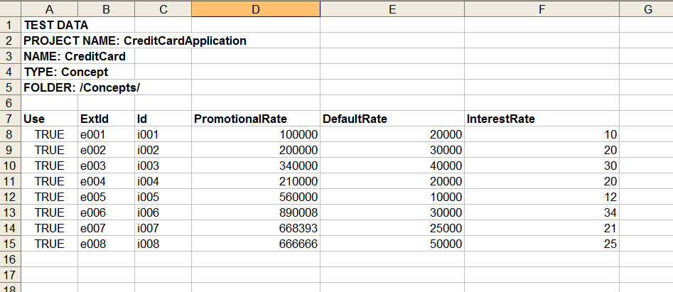

Test Data
Using the import command the user has to import test data entered in the template files to *.concepttestdat and *.eventtestdata files. These files are similar to files saved by Studio Tester on selecting create test data.

Test Data validation and fix
After conversion of test data from CSV file, the tester will do validation such column properties mismatch check with the corresponding concept/event/scorecard, type check, duplicate external IDs (within the same test data file or directory) and will throw errors, if any, so that user has to fix those in the CSV file.

Result Data
After the assertion, the results will be saved in an output directory, provided in the user command line options, described in command line options.

Default Format
The format options may be either in xml format (default) or html format (through command line option)

Custom Format
The user can generate the output either in Types based or Operation (i.e. Created, Modified and Deleted). The default output is generated with Operation based.

Command Line Usage and Options

The “-tester” operation of studio-tools provides following commands:

Generate Test Data templates
The “generate” command reads concepts, scorecards and events from a project and creates test data template files in comma separated format. The output files can be edited by the user to add test data and then can be used as an input for the “import” command to import the test data.

Usage:

studio-tools –tester generate [-h] [-o <outputDirectory>] -p <projectDir> [-t < xls | csv >] [-s <separator>] [-x]

Options:

-h | (optional) | Prints usage help
-o | (optional) | Specifies the output directory. If not specified, the output directory will be ProjectDirectory/TestDataTemplates
-p | (required) | Specifies the project path
-t | (optional) | Specifies the output file type. Supported values are [ xls | csv ]. If this option is not specified then the output will be in csv format with comma as a column separator.
-s | (optional) | Used only when the output file type is csv. It specifies the column separator to be used for csv files. Supported values are [ , | ; ]. If not specified the default column separator would be comma
-x | (optional) | Overwrites the output directory if it already exists.

Import CSV file to Test data
The “import” command reads the csv data files and converts it to the appropriate test data format (i.e .concepttestdata, .eventtestdata).

Usage:

studio-tools –tester import [-h] -i <inputFile> -p <projectDirectory> [-t < xls | csv >] [-s <separator>] [-o <outputDirectory>] [-x]

Options:

-h | (optional) | prints usage help
-i | (required) | Input path. This could either a path to a directory containing TestDataTemplate files, or a single TestDataTemplate file, or path to Listfile containing paths of files that are to be included in for test data generation.
-p | (required) | Specifies the project path
-t | (optional) | Specifies the input file types. Supported values are [ xls | csv ]. If this option is not specified then the output will be in csv format with comma as a column separator.
-s | (optional) | Used only when the output file type is csv. It specifies the column separator to be used for csv files. Supported values are [ , | ; ]. If not specified the default column separator would be comma
-o | (optional) | Output Path.
-x | (optional) | Removes the “TestData” root from under the output directory if it already exists and creates a new one.

Assert Test data
The “assert” command is used to assert the test data on a running be-engine instance.

Usage:

studio-tools –tester assert [-h] -p <projectDir> -c <CDD file path> -r <EAR file path> -w <working directory path> [-u <processing unit name>] [-i <input path> ] [-f <output format>] [-o <outputDirectory> ] [-n <name of result file>] [-x]

Options:

-h | (optional) | prints usage help
-p | (required) | Specifies the project path
-c | (required) | Specifies the CDD file path
-r | (required) | Specifies the ear file path
-w | (required) | Specifies the working directory path
-u | (optional) | Specifies the processing unit name. If not specifies it will use “default” processing unit.
-i | (optional) | Specifies the input directory path. If not specified then it will attempt to use the “TestData” directory under project directory.
-f | (optional) | Specifies the output format type. Acceptable values are “ops”, “type”. If this option is not specified then the default output is generated.
-o | (optional) | Output directory. If not specified the output directory would be project directory/results
-n | (optional) | Name of the resultFile. If not specified then it would create a file with name Run-#.resultdata
-x | (optional) | Overwrite if the output file already exists.

